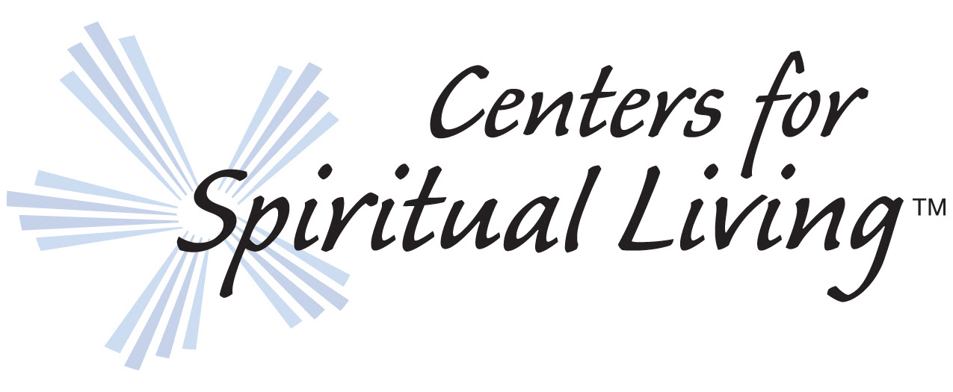

Standing with Religious Leaders of Faith

For Immediate Release
Call to Action for all Centers...
Please release this statement to your local media

January 30, 2017
Centers for Spiritual Living
Standing with Religious Leaders of Faith
Toward 'A World That Works For Everyone.'
(Golden, Colo.)

Centers for Spiritual Living stands in solidarity with leaders and faith organizations who have spoken out about the Executive Order from the President of the United States of America that bans immigrants from seven majority Muslim nations, including Syria, whose residents have been subject to ongoing deadly civil war.
Centers for Spiritual Living embraces the United States of America’s values of life, liberty, and the pursuit of happiness, which to us means the inclusion of all people. Therefore, we affirm what is written at the base of the Statue of Liberty: Give me your tired, your poor, your huddled masses yearning to breathe free, the wretched refuse of your teeming shore. Send these, the homeless, tempest-tossed to me; I lift my lamp beside the golden door!
We stand in solidarity with religious faith leaders who believe that it is possible to create a world that works for everyone without loss of human rights or national security. In following the example set by Jesus, who in Matthew 12:13 said, "Stretch forth thine hand," our organization extends our hand out to others to promote good will, love, and compassion in the form of this affirmation of our solidarity.
In the spirit of Rev. Dr. Martin Luther King, who stated that our lives begin to end the day we become silent about things that matter, we choose not to be silent and instead, we appeal to our leaders to work toward human dignity and compassion for those who turn to our nation for help.
Centers for Spiritual Living values and celebrates the individual uniqueness and contribution of all people as they express through differences of gender, ethnicity, culture, history, experience, talents, and sexual orientation. Therefore we commit to speak for, and stand with, those who are working diligently to uphold our constitution and our bill of rights by protecting human rights and the dignity of al people. We commit to standing with those who refuse to discriminate on the basis of race, religion, nationality, gender, or sexual orientation.

Centers for Spiritual Living
Rev. Dr. Kenn Gordon - Spiritual Leader
Rev. Dr. John Waterhouse - Field Leader
Rev Dr. David Alexander - Leadership Council Chair
Steve Burton - Executive Director

Centers for Spiritual Living 573 Park Point Drive Golden, Colorado, 80401
Phone: 720-496-1370 | Fax: 303-526-0913 | Email: receptionist@csl.org

